Lil’ People’s World Newsletter
Fall 2020
I am so grateful for our whole LPW community. There have been many changes to how our center program operates and functions during these wearisome times. Our Teachers, Families have been amazing and our kiddos resilient. I am so proud to be a part of all our accomplishments. Thank you all for being patient and understanding as we all navigate through these times.
Each day is something new for all of us, and we will continue to keep everyone updated to new procedures and protocol as once we know the information. We are adjusting our curriculums and procedure to ensure that we continue to provide a healthy environment for us all.
Starting this fall School-Agers will be with us throughout the day. We are still working out how this will look in center and we are waiting for more information from the school districts so we can fine tune what we have come up with. We are currently putting things in place as we wait to hear on what those schools will come up with. Look for information in the coming weeks.
We had so many cool activities and events planned, but what is exciting is that we will be trying some new things and that we are working creatively as a community, which is always great to see.
Once again, thank you to all my LPW families and professional peers for being rock stars these last 6 months. It is crazy to say 6 months, but we have passed that milestone. YOU ARE ALL AMAZING!
-Miss Jenee

This Issue…
Letter from Director, FALL Edition P.1
Upcoming Events and Center Closures P.2
Celebrate, Books and Children.3
Featured Family, Staff of the Quarter and Recipe P.4

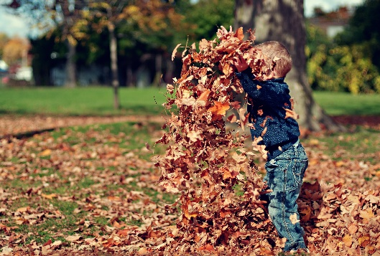
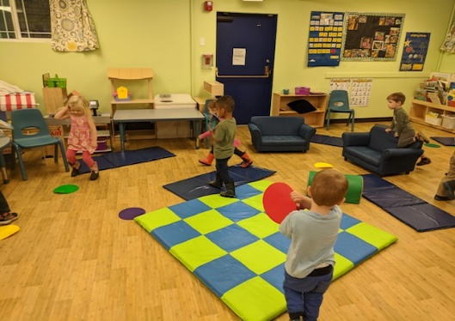

Featured FALL Art
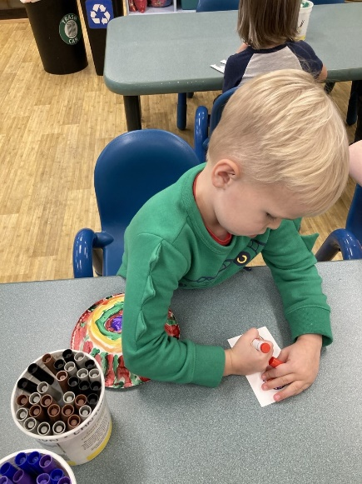
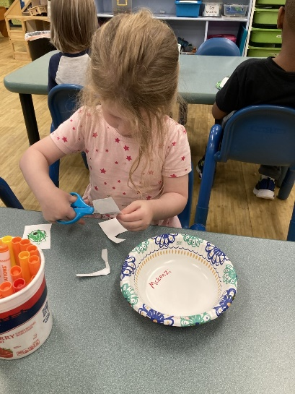
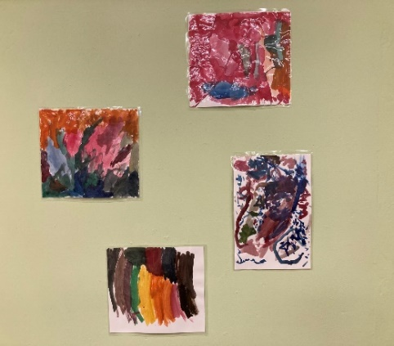

Canyon
Upcoming Events

- BACK TO SCHOOL PLANNING-This year it sure looks different! Be sure to touch bases with us about your family’s needs and how we can help.
- PUMPKIN PAINTING- On Wednesday October 7th we will be painting pumpkins in our classrooms. Please make sure your kiddos are ready to get paint all over their clothes. .
- COSTUME DANCE PARTY- We will be celebrating Halloween a little different this year, Friday October 30th. We are having amazing dance parties in the classrooms at 3pm. We encourage kids to have costumes or fancy wear. Look for pictures on our social medias.
- PORTFOLIO WEEK- November 2nd through the 6th is Portfolio week. We have scheduled days for viewing of your child’s Portfolio. Get ready to see some amazing work.
- TURKEY LUNCH- November 25th our kiddos get to have a feast of Turkey meal to celebrate Friendship and giving. We are so grateful and thankful to have these kiddos apart of our center.
- HOLIDAY BOOK Library DRIVE- December 7th through the 11th. We will be collecting Books and Funds to start and build an outdoor Book Library for our community. Please be a part of this exciting adventure. We can’t wait to see the smiles.

Center Closures
- September 7th-Closes Labor Day
- October 23rd- In-Service Day
- November 26th &25th- Thanksgiving
- December 24th &25th- Christmas

Here are some fun Fall books for kids:
1.The Busy Little Squirrel by Nancy Tafuri
2. Bella’s Fall Coat by Lynn Plourde
3. Fall Mixed Up by Bob Raczka
4.Fall Is Not Easy by Marty Kelley
5. Goodbye Summer, Hello Autumn by Kenard Pak
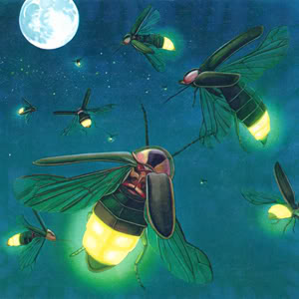

SEPTEMBER- Miss Fran (12yr), Miss Caitlin (1yr), Miss Diana (2y
OCTOBER- Miss Keiko (1yr), Mr. Gio (1yr)
NOVEMBER- Miss Christine (1 yr),
DECEMBER- Nobody.

Happy Anniversary to these amazing Teachers!!

LPW Children Share Their Favorite Things About FALL

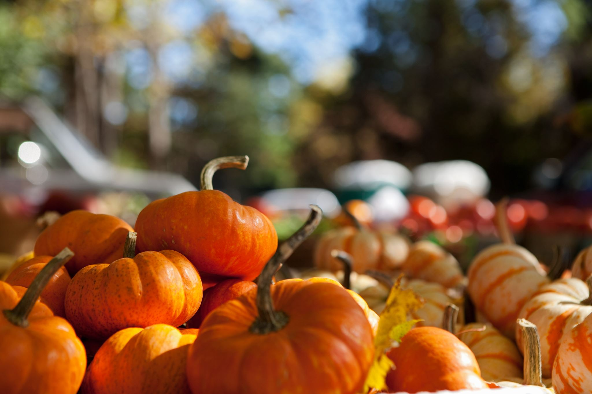
“In fall, the leaves can fall” – Abe 4
“I like the leaves changing colors” – Maxwell 5
“I like to play in the pile of leaves because fall is so fun” – Julia 4
“Wearing pants!” – Nicholas 4
“Getting cold because I love the cold” – Ethan 5
“I wanna be Belle for Halloween!” – Vera 3
“I like when it’s dark outside and the pumpkins are scary” – Kai 3
“Katie May and I get to go on a tractor!” – Evalina 3

LPW Featured Family: The Townsends
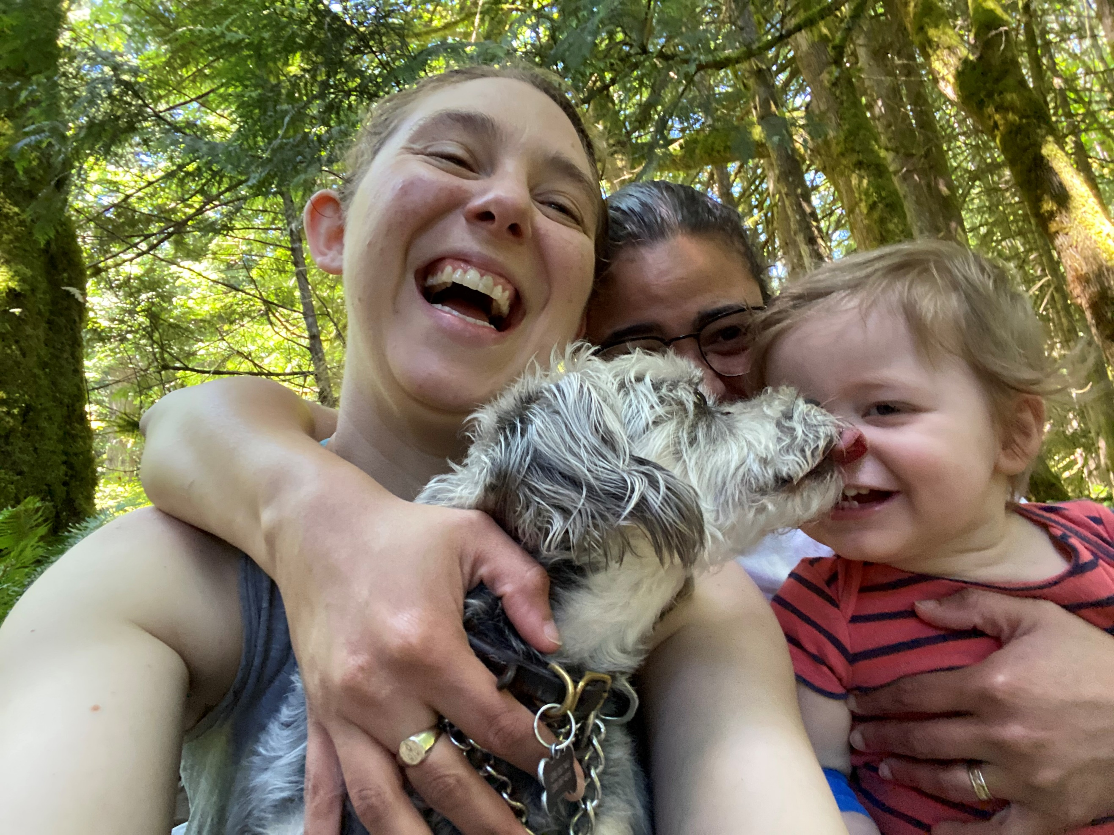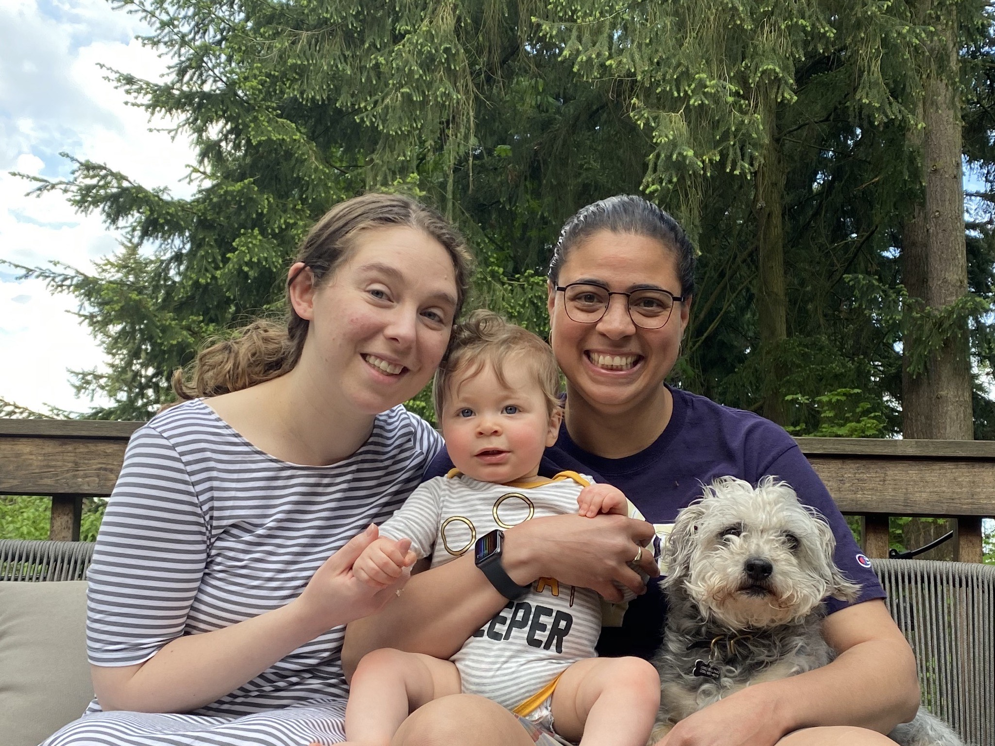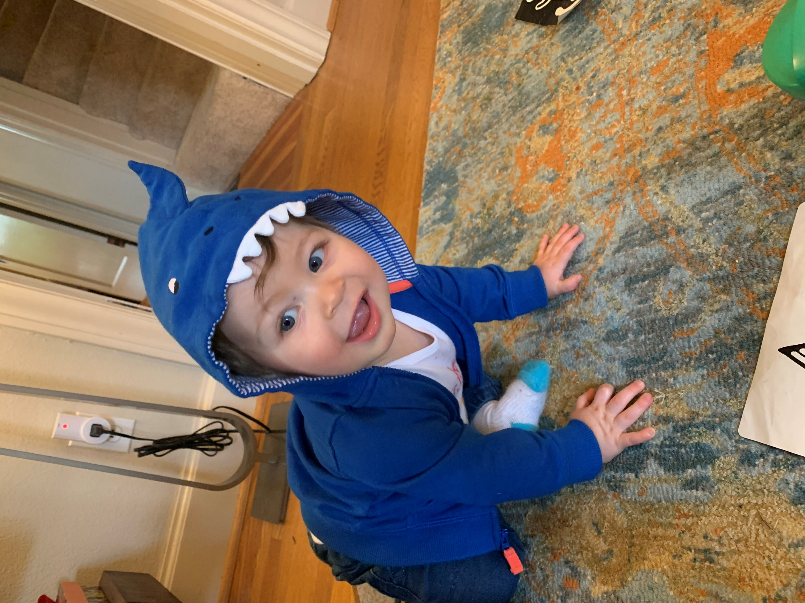

Diego Townsend and his moms, Rachel, and Tania, along with their dog, Benji, live here in the Haller Lake neighborhood (and enjoy a very short commute to LPW!). Diego started at Lil' People's World in February this year and just turned 1 on July 15th! The Melo-Townsend family enjoys family walks around the neighborhood, crawling around the house together, and exploring new places on hikes. We are all looking forward to getting to know the LPW community better as Diego gets a bit older and more involved
Featured Employee of the Quarter

Congratulations
Miss Christine

Miss Christine is a caring and hard working part of our team. She is versitile and has built great relationships throughout the center.
Miss Christine has two kiddo’s of her own that she takes on lots of adventures, as well as very cute cat.

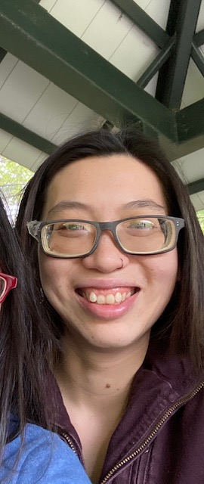

Recipe of the Quarter

Mini Quiche
One of our favorite fall treats is mini quiche! Far from being complex, these simple bite sized
yummies are easy to whip up, and even more fun to make with kids!
You’ll need: a greased muffin tin, a roll of pillsbury flaky rounds, about half a dozen eggs, and
Some yummy stuff to add to your quiche – we like crispy bacon, swiss or gouda crumbles
and spinach, but you can add what sounds good to you!

- Separate rounds into thin layers, and line muffin tins.
- Spoon whipped egg mix into each muffin cup until half full.
- Add your quiche goodies, preserving some cheese to use as a topping.
- Bake for 10-12 minutes at 350 – checking every 5-6 minutes with a toothpick.
- When the tooth pick comes clean, turn off oven, sprinkle left over cheese on top of
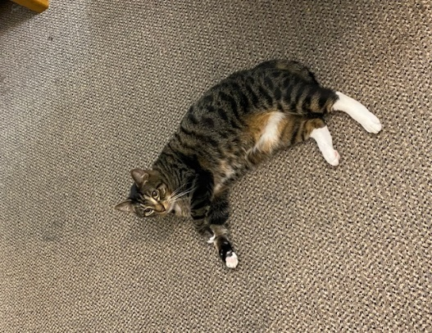
Mini quiche and close oven for a few moments to let melt.
Voila! Your treats are ready, and go well for family brunches, lunches and quick breakfasts
on the way to school or work!

